Implementation of the Recovery and Resilience Plan in Malta: Achievements and Challenges
Annual Conference
09:00 -13:00, 8 November 2023

Pictures and short biographies of participants

Title | Name | Picture |  | Short biography
Moderator | Keith Demicoli | 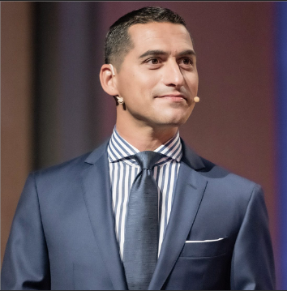 |  | Freelance broadcaster and communicator.
Head of European Commission Representation in Malta | Lorenzo Vella | 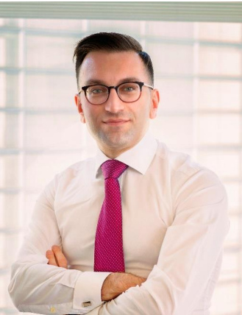 |  | Head of the European Commission Representation in Malta since May 2023. Formerly Malta’s Permanent Representative to the Council of Europe (2021-2023), and Deputy Permanent Representative of Malta to the European Union.
Director-General, SG-RECOVER, European Commission | Celine Gauer | 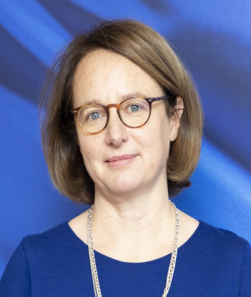 |  | Director General of the Recovery and Resilience Task Force. Deputy Secretary General for Policy Coordination in the European Commission (2018-2020). Former member of the Directorate General for Competition, where she occupied various positions, most recently as Director for Energy and Environment.
Parliamentary Secretary for European Funds, Ministry for Economy, European Funds and Lands | Hon. Dr Chris Bonett | 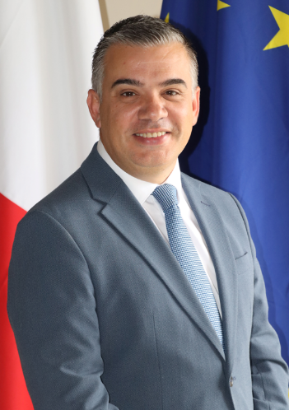 |  | Elected to Parliament and appointed Parliamentary Secretary for European Funds within the Ministry for Economy, European Funds and Lands in March 2022. Served as Mayor of Gżira.
Divisional Manager, Interconnect Malta | Dr Ing. Joseph Vassallo | 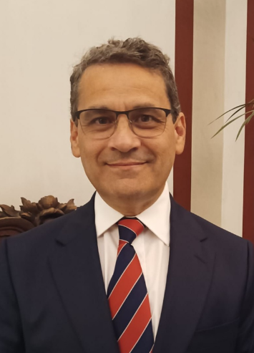 |  | An electrical engineer, currently leading a team at Interconnect Malta working on the second electrical interconnector with Italy, offshore renewable energy and battery storage projects.
Chairman, Malta Council for Economic and Social Development | David Xuereb | 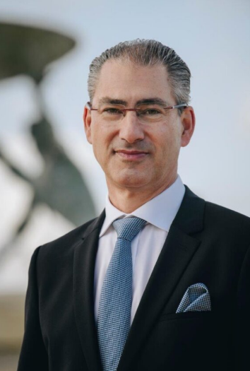 |  | Chairs the Malta Council for Economic and Social Development (MCESD) and the Malta ESG Alliance. As an architect and structural engineer, he has led built-environment teams around the world for over 30 years. Lectures at the University of Malta. Presided over the Malta Chamber of Commerce.
Director, Institute for Sustainable Energy, University of Malta | Prof. Luciano Mule Stagno | 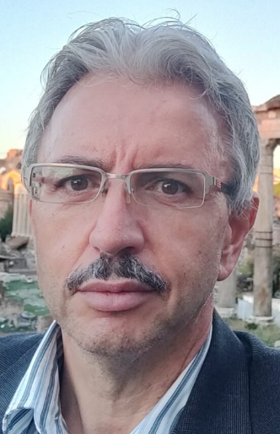 |  | Director of the Institute for Sustainable Energy. He spent 12 years with MEMC Electronic Materials in the USA as Director of worldwide labs. His major expertise is in semiconductors and solar materials, but he has also worked on offshore solar and solar systems. Former CEO of Heritage Malta and currently council member of Din l-Art Ħelwa. Served on the boards of several local companies.
Climate Campaign Coordinator, Friends of the Earth Malta | Dr Suzanne Maas | 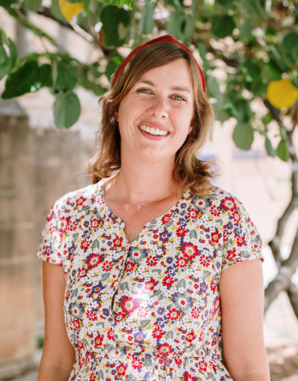 |  | As Climate Campaign Coordinator at Friends of the Earth Malta, Suzanne focuses on climate, energy and mobility. The climate campaign promotes a fossil-free vision for Malta and investment in renewable energy, community energy and cleaner modes of transport. Involved with the EIT Urban Mobility Hub in Malta, promoting sustainable mobility initiatives. Lectures part-time at the University of Malta.
Director, DG ECFIN, European Commission | Isabel Grilo | 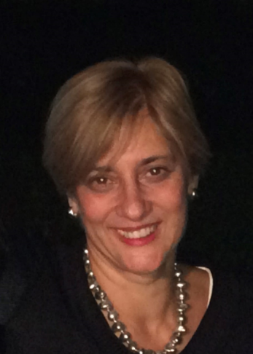 |  | Oversees the work on economic surveillance and co-leads the negotiations with eight Member States on the implementation of the Recovery and Resilience Facility. Before that, she headed the ECFIN Unit dealing with competitiveness and structural reforms. She was previously a scholar and researcher holding several positions at the Catholic University of Louvain and the University of Lille.
Minister for Education, Sport, Youth, Research and Innovation | Hon. Dr Clifton Grima |  | 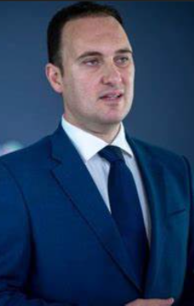 |  | Minister for Education, Sport, Youth, Research and Innovation A lawyer by profession, he was elected in Parliament in October 2016. Following the June 2017 General Election, was entrusted with a Cabinet role as Parliamentary Secretary for Youth, Sport and Voluntary Organisations.
CEO, The Malta Chamber of Commerce, Enterprise and Industry | Dr Marthese Portelli | 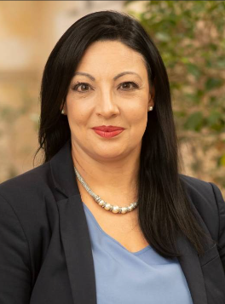 |  | Chief Executive Officer of the Malta Chamber of Commerce, Enterprise and Industry since June 2021. A law graduate, with a wealth of experience in policy formulation and negotiation. Occupied senior roles in the corporate world for 13 years in the technology sector, before serving as a Member of Parliament shadowing such portfolios as EU affairs, energy, environment, transport, infrastructure, capital projects, planning and property.
Secretary General, General Workers Union | Josef Bugeja | 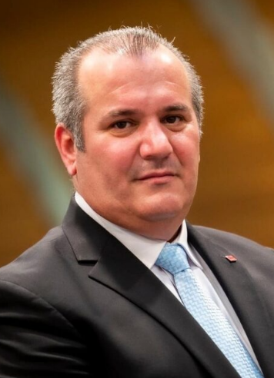 |  | After a long career in trade unionism occupying various roles, Bugeja was confirmed as Secretary General of the GWU in 2015. He represents the GWU in various national and international institutions like the Malta Council for Economic and Social Development, International Labour Organisation, European Trade Unions Confederation and the International Trade Union Confederation.
CEO, Junior Achievement Malta | Matthew Caruana | 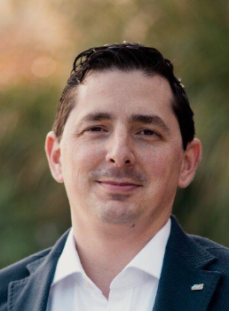 |  | Matthew Caruana is the CEO of Junior Achievement Malta, which provides education in entrepreneurship, financial literacy and work readiness. He has worked with students and youth as a business innovator, coach and mentor with a proven track record for driving project success from the grassroots up.
Director, DG GROW, European Commission | Mary Veronica Tovsak Pleterski | 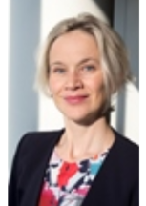 |  | Director for Single Market Enforcement at DG GROW in the European Commission. Former economic advisor to the President of the European Commission. Before that, a Director at DG ECFIN in charge of investment, growth and structural reforms. Was Director for European and international carbon markets at DG CLIMA and Principal Adviser at DG CNECT. Former Deputy Permanent Representative of Slovenia to the EU. Started her career in the Ministry of Foreign Affairs of Slovenia and served as a diplomat in Strasbourg, New York and Brussels.
Director General, Ministry for Economy, European Funds and Lands | Claude Sammut | 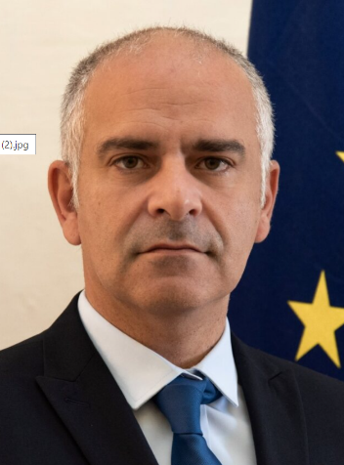 |  | Claude Sammut is the Director General of the Measures and Support Division, which is entrusted with the function of Intermediate Body for measures funded through the ERDF 2014-2020, the ERDF 2021-2027 and is also responsible for a number of schemes deployed under two investments in Malta’s RRP.
CEO, Servizzi Ewropej f’Malta (SEM) | Denise Fiorentino | 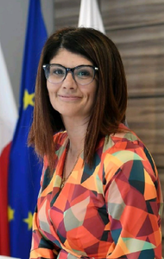 |  | Ms Fiorentino joined the public service in 2004. She has over 10 years of experience in the EU funding sphere, having worked both on the policy and implementation dimension of EU-funded initiatives.  Specialising in policy drafting, Ms Fiorentino was also responsible for the programming of the Operational Programmes of Malta’s Structural Funds 2014-2020. She is currently CEO of Servizzi Ewropej f’Malta – the Government’s helpdesk for EU Funds, focusing on improving the accessibility of EU-funded initiatives for all.
CEO, Malta Chamber of SMEs | Abigail Mamo |  |  | Chief Executive Officer of the Malta Chamber of SMEs for the last nine years. Her expertise revolves around competitiveness and sustainability of enterprises, especially SMEs. An experienced lobbyist, representing the interest of businesses on a number of high-level fora.
CEO, Gozo Business Chamber | Daniel Borg | 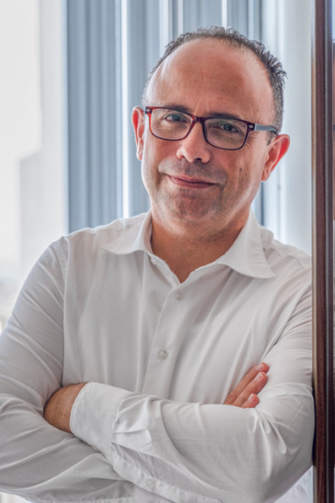 |  | Chief Executive Officer of the Gozo Business Chamber, after having occupied various roles within the public sector.  Currently a member of the technical committee of Insular Chambers of Commerce of the EU, and a board member of the Gozo Regional Development Authority.

